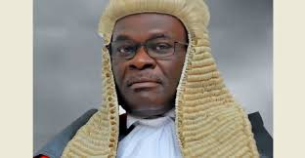

**HON. JUSTICE ALFONSE CHIGAMOY OWINY-DOLLO**

**(CHIEF JUSTICE OF THE REPUBLIC OF UGANDA**

Hon. Justice Alfonse Chigamoy Owiny-Dollo, Chief Justice of Uganda since 2020, brings over three decades of distinguished legal experience. His career spans roles as Deputy Chief Justice, private legal practitioner, and a delegate in the Constituent Assembly that framed the 1995 Constitution.

A passionate advocate for Alternative Dispute Resolution (ADR), Justice Owiny-Dollo holds advanced qualifications in Conflict Resolution and International Commercial Arbitration, and he chairs the African Chief Justices Forum on ADR. Notably, he has contributed to peacebuilding in Uganda, including landmark negotiations with Joseph Kony during the country’s internal conflict.

Justice Owiny-Dollo’s leadership and expertise continue to shape Uganda’s Judiciary and its pursuit of justice and peace.



**HON. JUSTICE RICHARD BUTEERA**

Hon. Justice Richard Buteera, the Deputy Chief Justice of Uganda and the Head of the Court of Appeal / Constitutional Court, a position he has held since September 2020. With over 40 years of experience in the legal profession, Justice Buteera has served in various prominent roles, including as a Justice of the Supreme Court, Director of Public Prosecutions, and Chief Registrar of the Courts of Judicature. He is also the Chairperson of the Case Backlog Committee, leading efforts to reduce case backlogs within the Judiciary.

Justice Buteera holds degrees from Makerere University and Pepperdine University, including a Master of Laws in Alternative Dispute Resolution. A passionate mentor to young lawyers, he is the Patron of the Association of Uganda’s Prosecutors and is known for his humility, dedication to justice, and remarkable leadership in the Judiciary. We are honored to have him present today

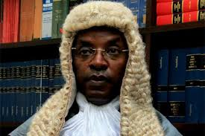

**HON. JUSTICE DR. FLAVIAN ZEIJA**

**Hon. Justice Dr. Flavian Zeija** is a renowned Ugandan lawyer, academic, and the Principal Judge of the High Court of Uganda since December 2019. As the third-highest-ranking judicial officer in the country, he oversees the operations of High Court judges and supervises Magistrates Courts.

The Principal Judge holds a Bachelor of Laws, Master of Laws, Ph.D. in Law, MBA, and membership in the UK Institute of Chartered Secretaries and Administrators.

With over two decades of experience in legal practice and academia, His Lordship has worked as a legal practitioner, law lecturer, and High Court Judge since 2016, significantly contributing to Uganda’s judiciary.

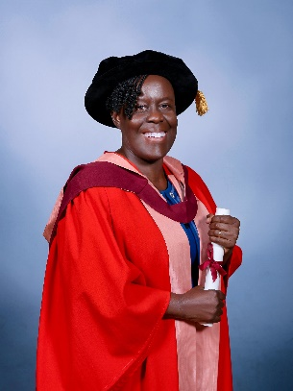

**Lady Justice Prof. Lillian Tibatemwa-Ekirikubinza (Ph.D.; LL.D (Honoris Causa))**

Justice Prof. Lillian Tibatemwa-Ekirikubinza has been a Justice of Uganda’s Supreme Court since 2015 and is a trailblazer in both the judiciary and academia. She holds a Ph.D. in Law, a Master’s in Commercial Law, and an LL.B (Hons) degree. She was the first East African woman to earn a Ph.D. in Law and the first to attain full professorship in the discipline. She also made history as the first female Deputy Vice-Chancellor and Acting Vice-Chancellor of Makerere University.

A prolific legal scholar, she has authored widely referenced law textbooks and numerous academic papers. Her most recent publications focus on electoral justice and gender-based violence in Africa. In recognition of her contributions to legal education and justice, she was awarded an honorary Doctor of Laws (LL.D) by the University of Bristol in 2023.

She currently serves as a Commissioner on the International Commission of Jurists and as Vice-Chair of the Board of the Africa Judges and Jurists Forum.

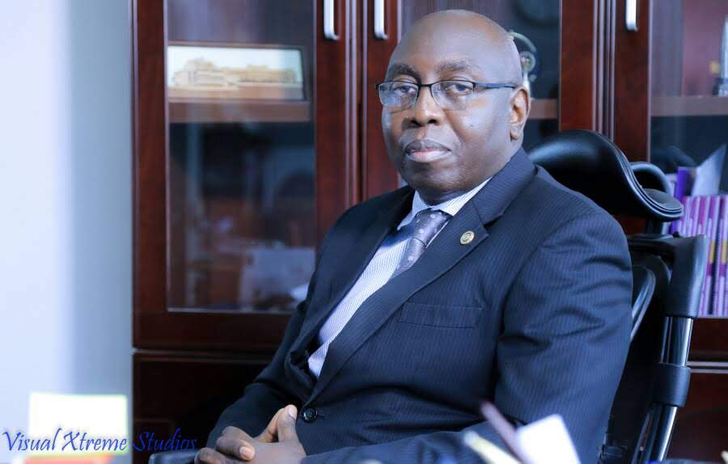

**Justice Geoffrey W. M. Kiryabwire CStJ; FCIArB**

Justice Geoffrey W. M. Kiryabwire, a Justice of Uganda’s Court of Appeal and Constitutional Court, is an expert in alternative dispute resolution and a Fellow of the Chartered Institute of Arbitrators, London. He previously served as Vice President of the East African Court of Justice and authored Alternative Dispute Resolution: The Uganda Court Experience. He is also deeply involved in community service and charity.

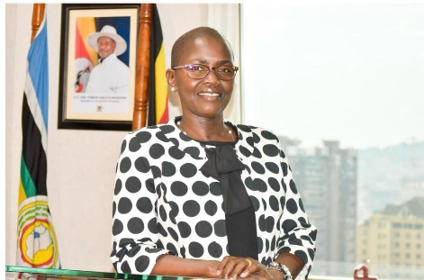

**LADY JUSTICE JANE FRANCES ABODO**

Lady Justice Jane Frances Abodo is the Director of Public Prosecutions (DPP) of Uganda and the first woman to hold this position, she was appointed in March 2020.

She is a former High Court Judge in the Criminal Division, with over 19 years of prosecutorial experience.

Judge Jane has also spearheaded reforms in prosecutorial practice, staff welfare, and the establishment of East Africa’s first virtual prosecutors’ academy.

An award-winning legal professional, she holds advanced degrees in law and conflict studies and has trained extensively in anti-corruption, financial investigations, and gender-based violence. She is currently pursuing a PhD.

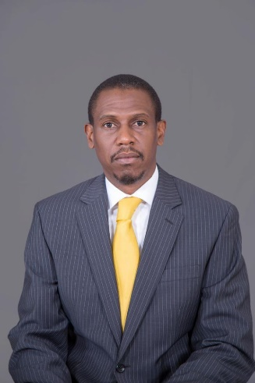

**KIRYOWA KIWANUKA**

Mr. Kiryowa Kiwanuka, the Attorney General of Uganda, is a seasoned legal expert with extensive experience in litigation across Uganda and the East African Court of Justice. A co-founder of K&K Advocates, he holds an LLM in Petroleum Law and Policy (University of Dundee) and has served on the Petroleum Authority of Uganda and Makerere University Council. He is a member of the Uganda Law Society, Chartered Institute of Arbitrators, and an Insolvency Practitioner, making him a highly accomplished litigator, advisor, and negotiator.

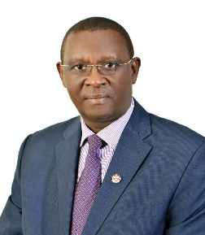

**DR. PIUS BIGIRIMANA**

Dr. Pius Bigirimana serves as the Permanent Secretary and Secretary to the Judiciary of Uganda, bringing over 30 years of Public Service experience. Dr. Bigirimana has demonstrated transformational Leadership in many entities he has worked, notably, the Office of the Prime Minister where he was instrumental in the implementation of the Peace Recovery and Development Programme (PRDP) which saw Northern Uganda recover from several years of turmoil. He also spearheaded the introduction of the Annual Performance Assessment Mechanism for the entire Government.

In Ministry of Gender, Labour and Social Development, he spearheaded the development of Youth Livelihood Programme and Uganda Women Entrepreneurship Program which focused on empowering Youth and Women with enterprises that generate income.

Since 2019, he has led the modernization of Judicial Process, notably, implementing Electronic Court Case Management Information System (ECCMIS) to enhance Justice delivery. He is also credited for Mobilization of resources and supervision of the construction of the Supreme Court and Court of Appeal, one of the flagship projects in the Judiciary.

His, “I can do it” attitude with Abundance Mentality has made him cause numerous transformational programs in the Judiciary. It is therefore no wonder that at one time, H.E. the President described Dr. Pius Bigirimana as a Pumpkin Seed which you can throw anywhere and it sprouts and flourishes. In September 2024, Dr. Bigirmana was elected Chairperson of the Southern and Eastern Africa Judicial Administration Association (SEAJAA), underscoring his commitment to regional Judicial excellence.

He holds an honors degree from Makerere University, two Masters degrees, one from the University of Manchester and another from Eastern and Southern Africa Management Institute (ESAMI). He is an accomplished author of six books and a dedicated Philanthropist who operates a Health Center in Kisoro district through Clare Nsenga Foundation providing affordable health care to over 12,000 patients annually.

Dr. Bigirimana is a doctoral candidate at Uganda Management Institute perusing a doctorate of Philosophy in Public Administration and Management.

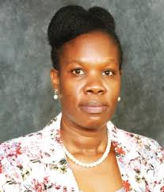

**DR. PATRICIA ACHAN OKIRIA**

Dr. Patricia Achan Okiria is the Deputy Inspector General of Government and Vice-Chairperson of the African Asset Recovery Practitioners’ Forum. She has served as a Commission Member of the Uganda Human Rights Commission and Policy Advisor at the Ministry of Works and Transport. She holds a Doctor of Laws (LLD) and a Master of Laws (LLM) in Human Rights.

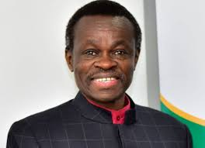

**PROF. PLO LUMUMBA**

**Keynote Speaker at the Uganda Annual Judges Conference**

Prof. PLO Lumumba is a renowned Legal Practitioner and Professor of Public Law. He holds Doctorates and many other qualifications in various disciplines.

Prof. Lumumba has served in various academic, legal, and leadership capacities, including as Director of the Kenya Anti-Corruption Commission and Director of the Kenya School of Law. He is a prolific author, having written extensively on criminal and constitutional law; ethics, and governance; and has delivered notable lectures globally, including the Kwame Nkrumah and Nelson Mandela memorial lectures. He is an advocate for Pan-Africanism who is recognized internationally for his commitment to fighting corruption, promoting good governance, and advancing African unity.

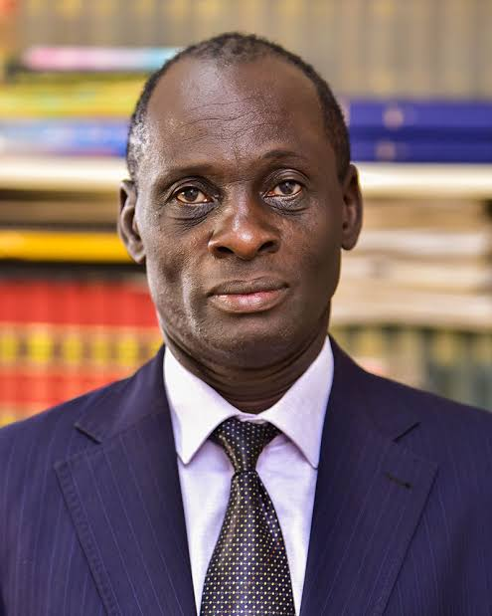

**TIBAJUKA KYOZAIRE ATEENYI CHARLES**

Tibajuka Kyozaire Ateenyi Charles is a legal practitioner, academic, and author. He chairs the University Staff Tribunal at Mbarara University and leads M/s Tibaijuka & Co. Advocates. An advocate since 1985, he has lectured widely and contributed to legal scholarship, bringing expertise in law, education, and ethics to this conference.



**PROF. PAMELA MBABAZI**

Prof. Pamela Mbabazi is the Executive Chairman of Uganda’s National Planning Authority and a Cabinet member, with extensive expertise in Development Studies. A former Deputy Vice Chancellor at Mbarara University, she has contributed significantly to academia, governance, and sustainable development in Africa. A prolific researcher and author, Prof. Mbabazi’s work focuses on oil governance, land policy, and peace building.

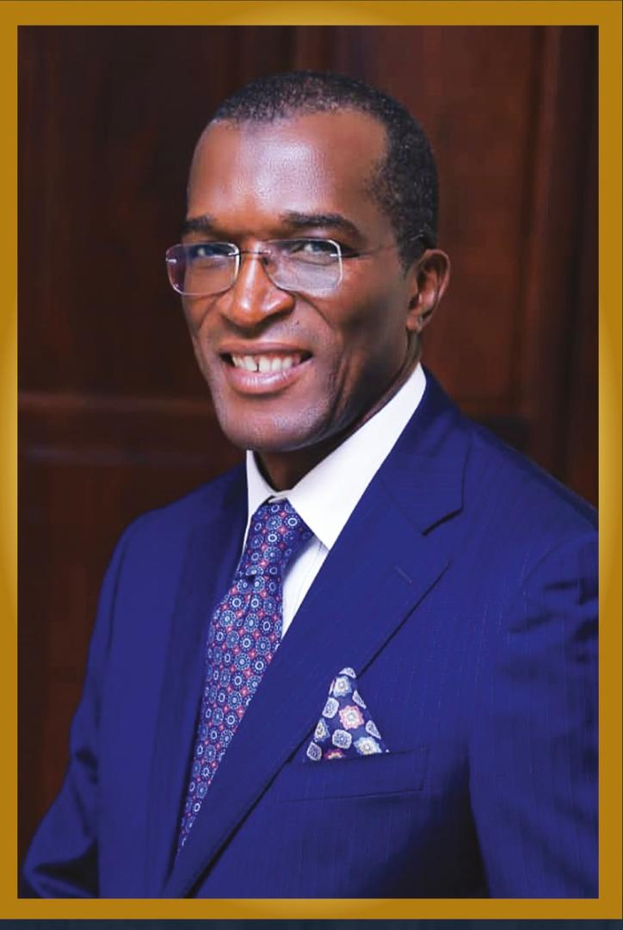

**ALHAJ KADDUNABBI IBRAHIM LUBEGA**

Alhaj Kaddunabbi Ibrahim Lubega, a Fellow of the Australian and New Zealand Institute of Insurance and Finance (ANZIIF), is the CEO of Uganda’s Insurance Regulatory Authority and Chairman of EAISA. With over 20 years of experience in finance, he has driven transformative reforms, including Bancassurance regulations, boosting Uganda’s insurance sector. A former MP, he holds advanced degrees in economics and is a passionate advocate for good governance.

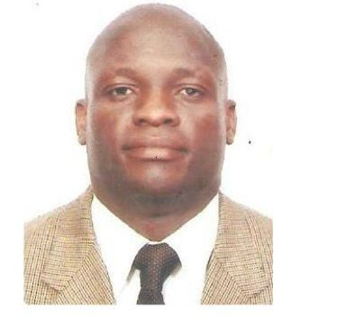

**ROBERT SSEBUGWAWO (COACH BOB)**

Robert Ssebugwawo, popularly known as Coach Bob, is a Preventive Health Specialist, Nutritionist, Fitness Expert, and retired global bodybuilder. Currently serving as a Fitness and Preventive Health Expert with the Parliament of Uganda, he has over 20 years of experience in health promotion and physical activity.

A member of the Exercise in Medicine Global Organization, Coach Bob is a passionate advocate for well-being, motivational speaker, and leader in global health initiatives.

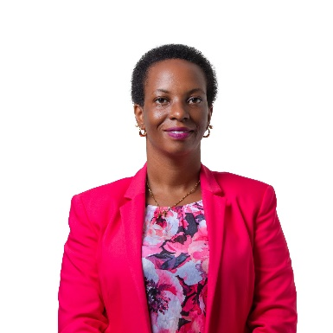

**MS. SUZAN TASHOBYA**

Suzan Tashobya is a counselling psychologist (MCPC) and Executive Director of Rapport Counselling – SMC Limited, a leading provider of Employee Assistance Program (EAP) services in Uganda. With over 10 years’ experience in counselling and psychosocial support, she specializes in workplace wellness and has designed and managed wellness programs for key institutions, including the Parliament and Judiciary of Uganda. Suzan is also a board member of the Exercise Is Medicine (EIM) project in Uganda.



**RUTH NASSUNA BALEMEZI**

Ruth Nassuna Balemezi is an Occupational Health Specialist with over 15 years of experience in treating occupational illnesses and injuries. She specializes in ergonomics, risk assessments, and developing health programs. Ruth is the founder of Nerves and Bones Rehabilitation Centre and has consulted for major organizations, including Stanbic Bank and TotalEnergies Uganda. She holds multiple advanced degrees in occupational health and rehabilitation.

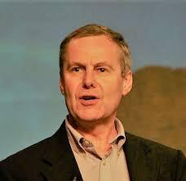

**REVEREND STEPHEN GAUKROGER**

With over 40 years in Christian leadership, Reverend Stephen has preached, taught, and consulted in over 50 countries. A former Senior Pastor and President of the Baptist Union of Great Britain, he now leads Clarion, a ministry dedicated to biblical teaching. A prolific author and global speaker, he leads us in prayer today.